**PROBLEM:**

**A program of Numerical Differentiation where F(x)= -0.1x4 -0.15x3-0.5x2-0.25x+1.2**

**OBJECTIVE:**

finding first derivative of given function using Forward,Backward & Centre Differences

**PROBLEM CODE:**

#include <bits/stdc++.h>

using namespace std;

double f1x;

double fofx(double x)

{

return -(.1)*x*x*x*x-(.15)*x*x*x-(.5)*x*x -(.25)*x+1.2;

}

double fdfx(double x)

{

return -(.4)*x*x*x-(.45)*x*x-x-.25;

}

double error(double val)

{

double ans=(fabs(f1x-val)/f1x)*100;

return (ans>0)?ans: (ans)*(-1);

}

int main()

{

double x,fx,h,x0,x1,fd,bd,cd,Err1,Err2,Err3;

cout<<"Give the value of x & h "<<endl;

cin>>x>>h;

x0 = x-h;

x1 = x+h;

fx = fofx(x);

f1x = fdfx(x);

fd = (fofx(x1) - fx )/h;

bd = (fx-fofx(x0))/h;

cd = (fofx(x1) - fofx(x0) )/(2*h);

Err1 = error(fd);

Err2= error(bd);

Err3= error(cd);

cout<<"Value of x using Forward Difference : "<<fd<<" Error: "<<Err1<<"%"<<endl;

cout<<"Value of x of Backward Difference: "<<bd<<" Error: "<<Err2<<"%"<<endl;

cout<<"Value of x Central Difference : "<<cd<<" Error: "<<Err3<<"%"<<endl;}

**OUTPUT:**

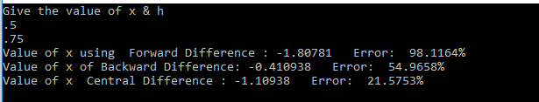

**DISCUSSION:**

In this lab,we learn to find the first derivative of a given function.Forward,Backward & Centre Differences for finding value & error.The centre Difference is relatively more efficient.